1. From the quick launch click **Documents**.

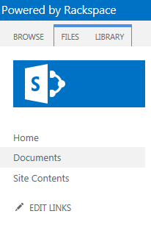

2. Notice there is already documents in this Document Library, from the ribbon click Files.

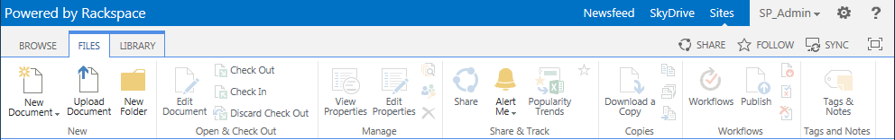

3. Click **New Folder**.  
  
4. In the Create a new folder window give it a name. (For this example I will call mine Training Materials)  
  
5. Click **Save**.  
  
6. The folder "Training Materials" is now in your Document Library.  
  
7. To move a document from your within your document library simply drag the document to the folder and release when it says "**Move**".  
  
8. Click on the **Training Materials** folder to open it and view your newly added document.

